Jeppiaar Institute of Technology

Sriperumbudur -631 604, Kanchipuram District, Tamil Nadu

DEPARTMENT OF INFORMATION TECHNOLOGY.

WEB PHISHING DETECTION

(**ASSIGNMENT 3)**

DATE : 23.11.2022

PROBLEM: TO ANSWER THE QUESTIONS FOR THE ANSWERS

NAME: DEVASASTHA

OUTPUT: SCREENSHOTS:

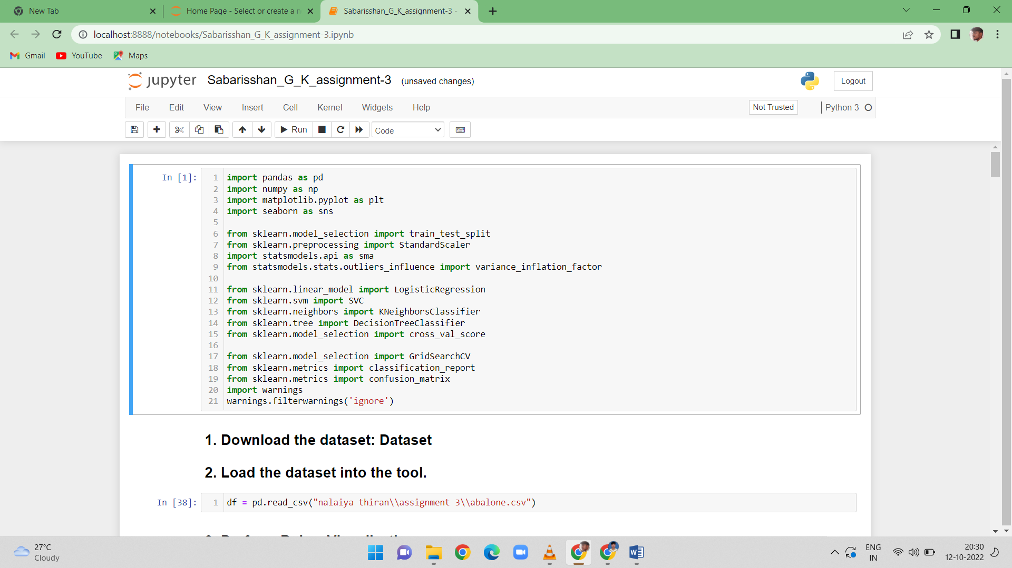

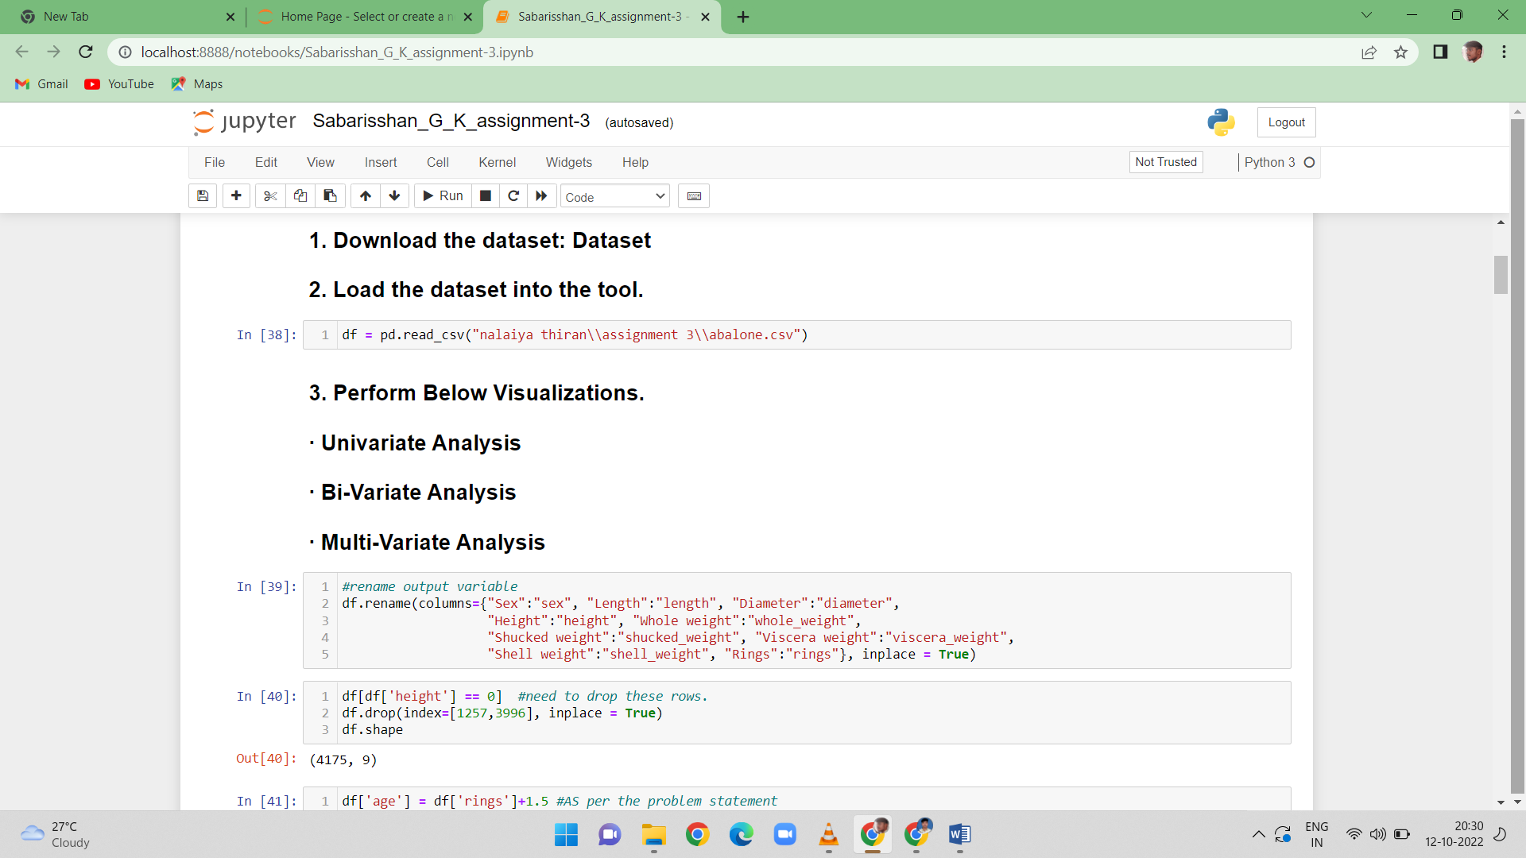

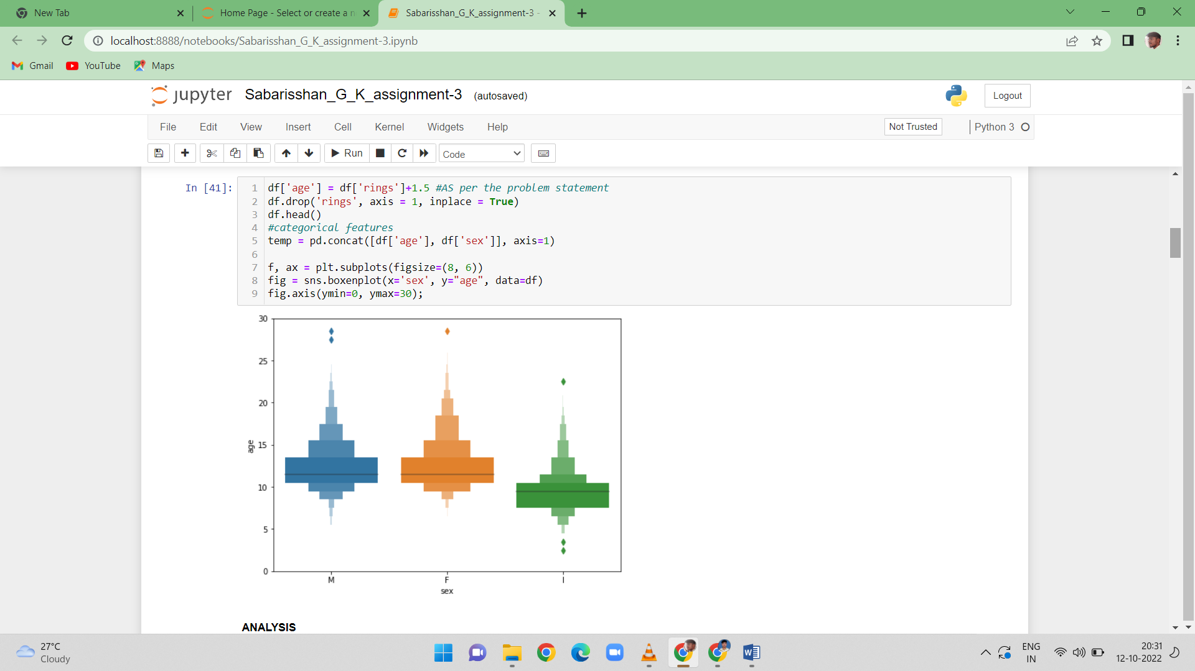

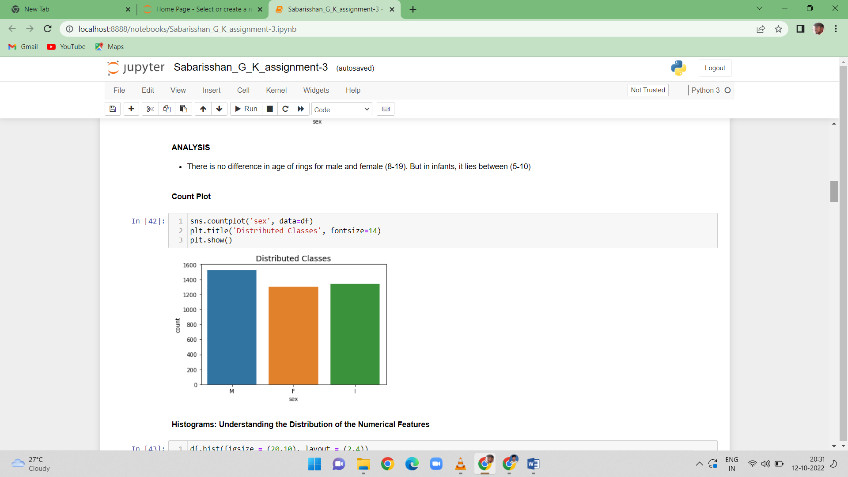

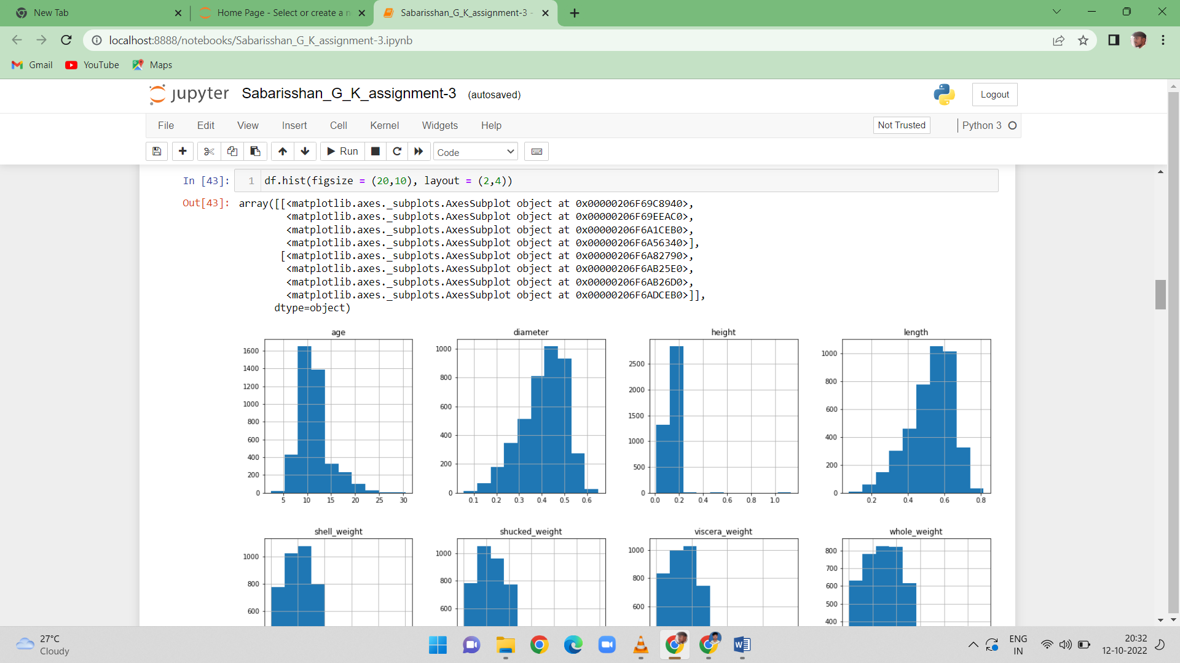

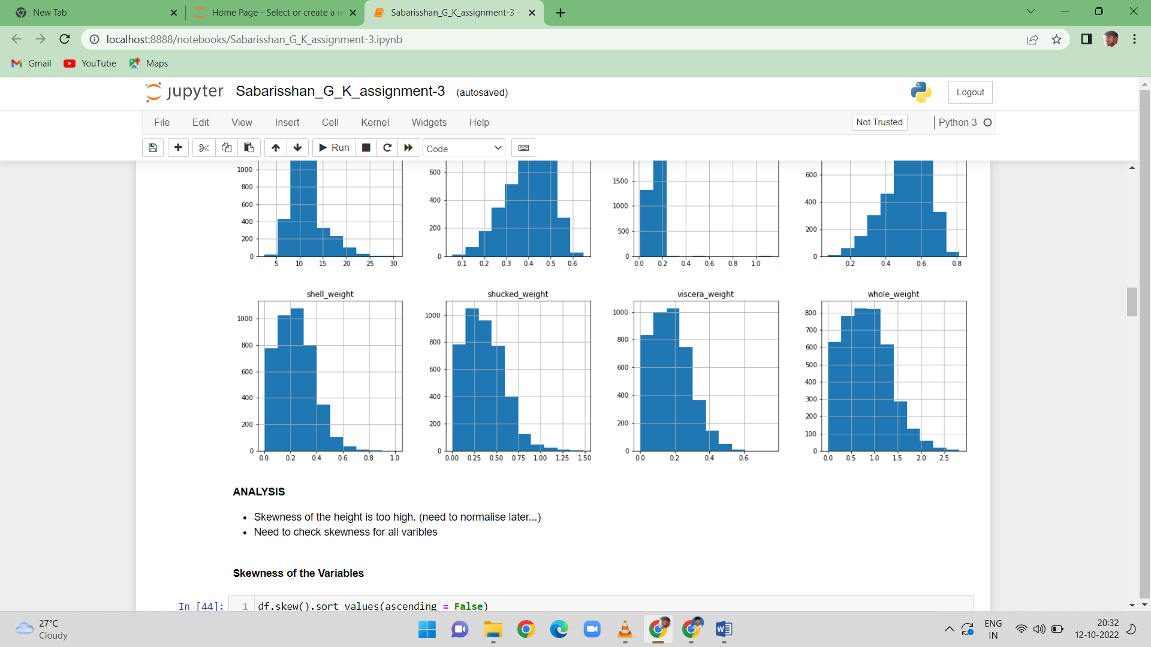

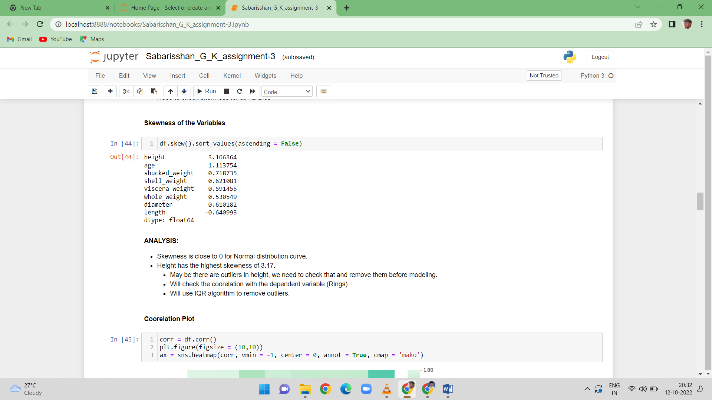

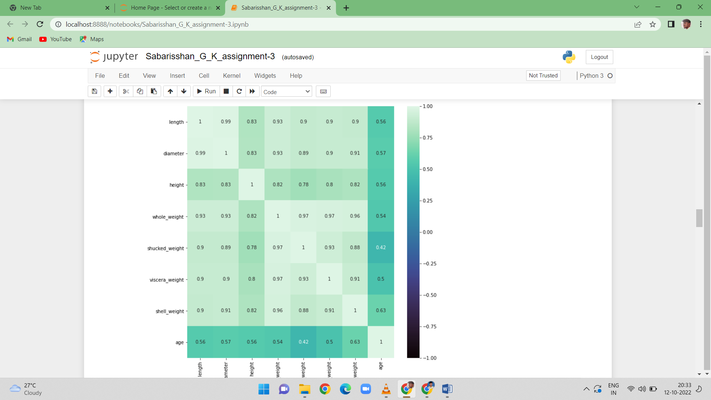

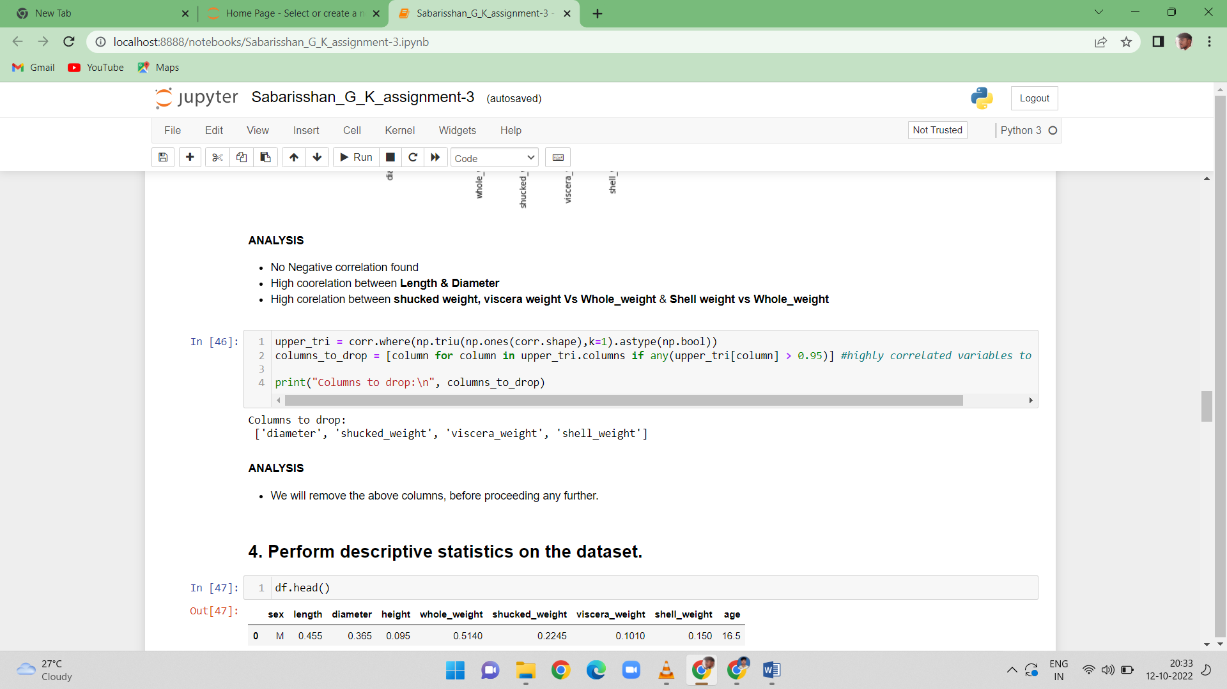

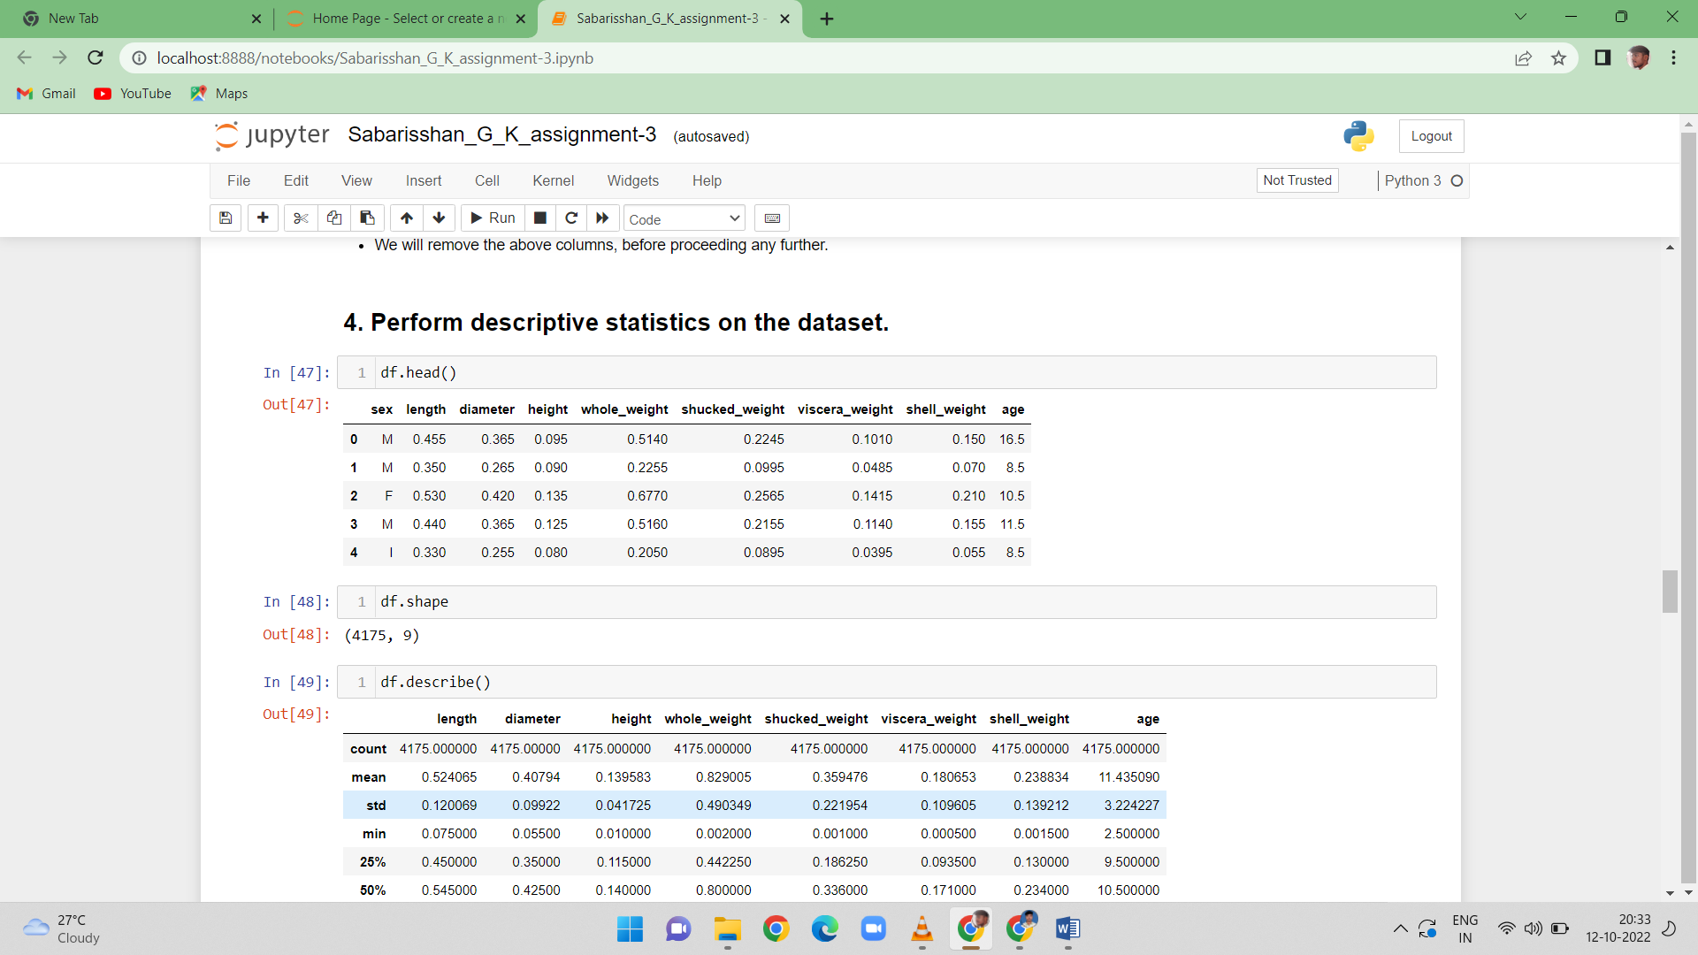

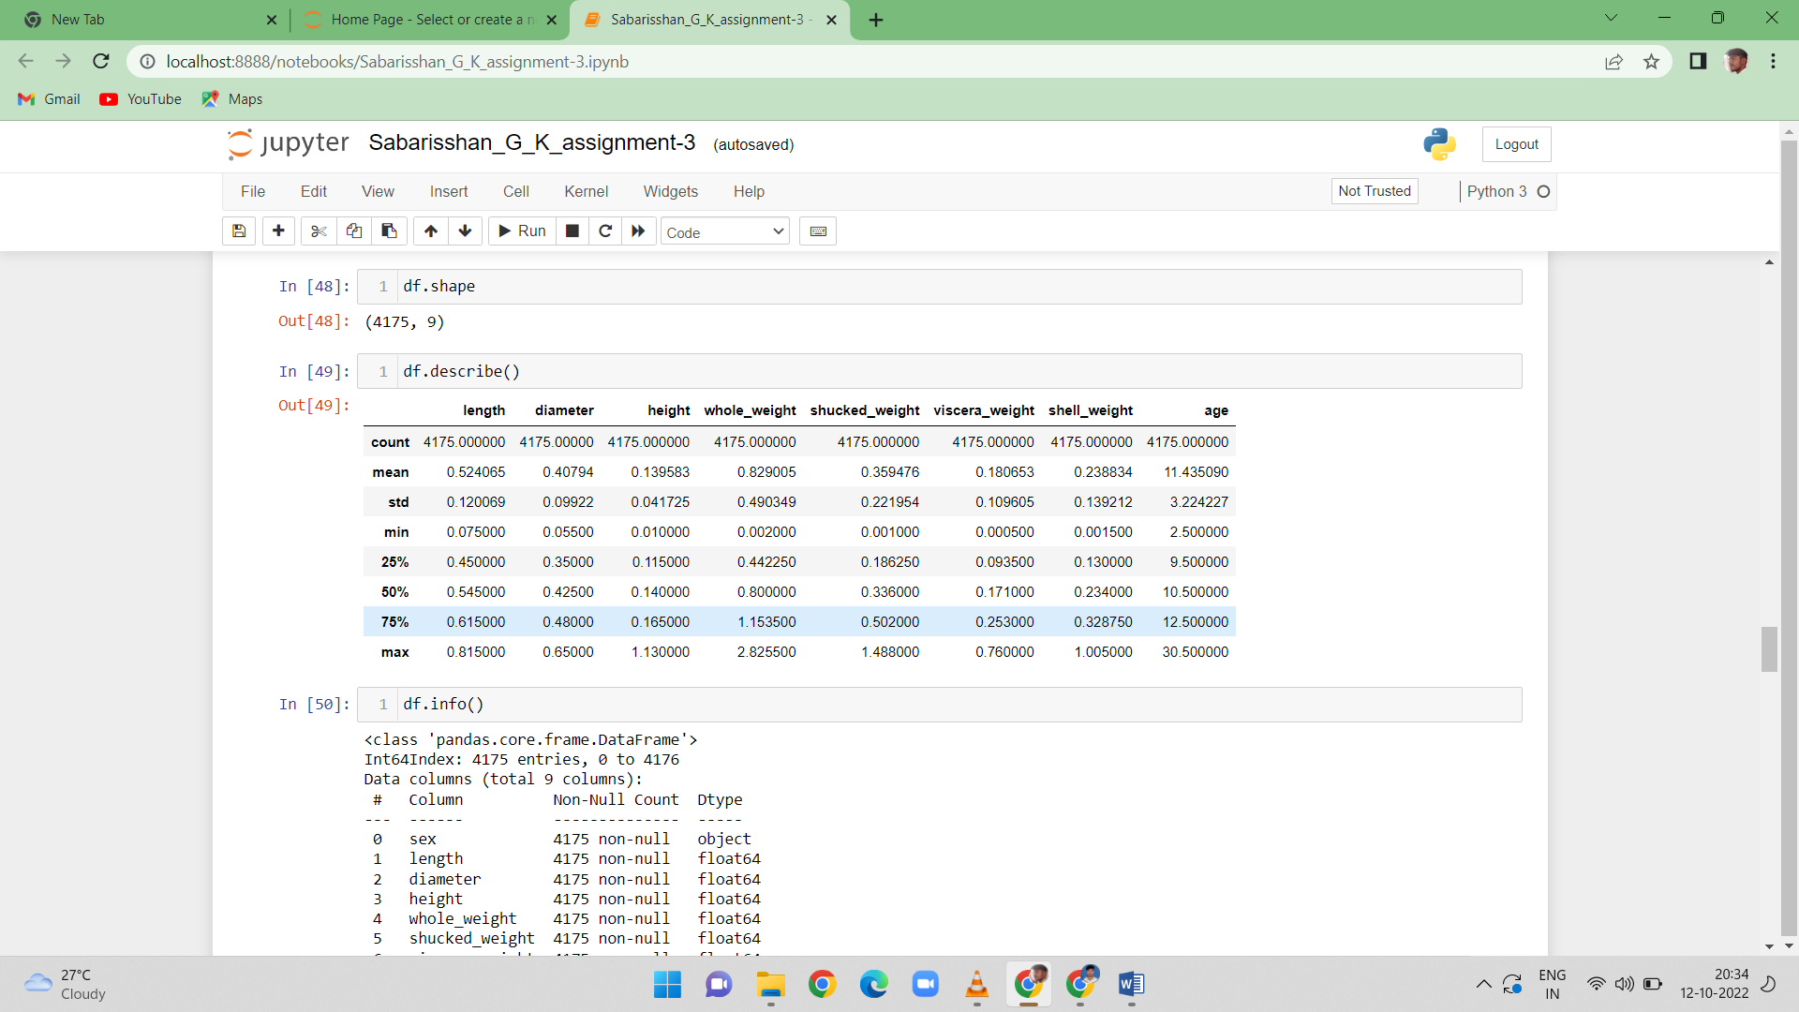

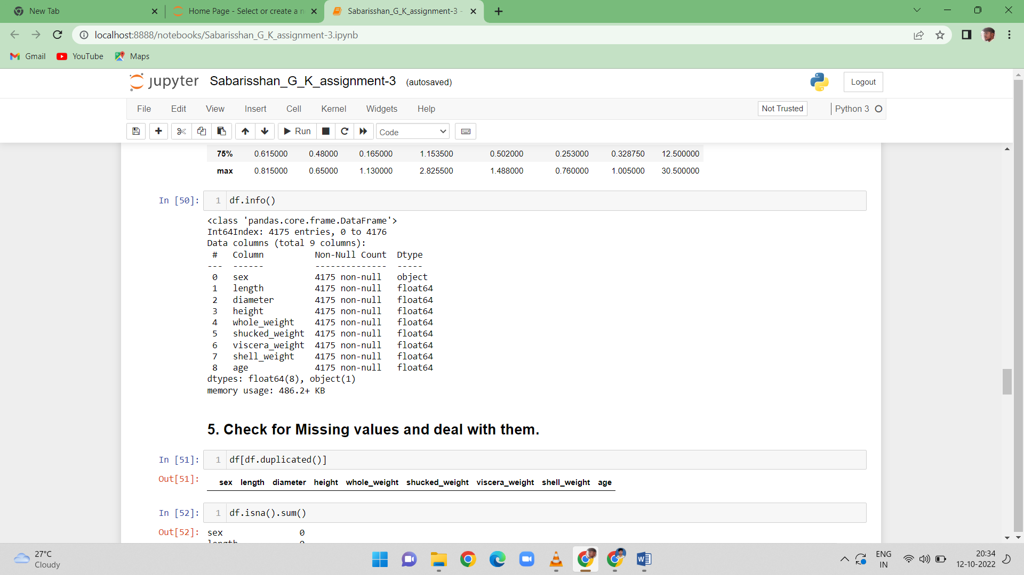

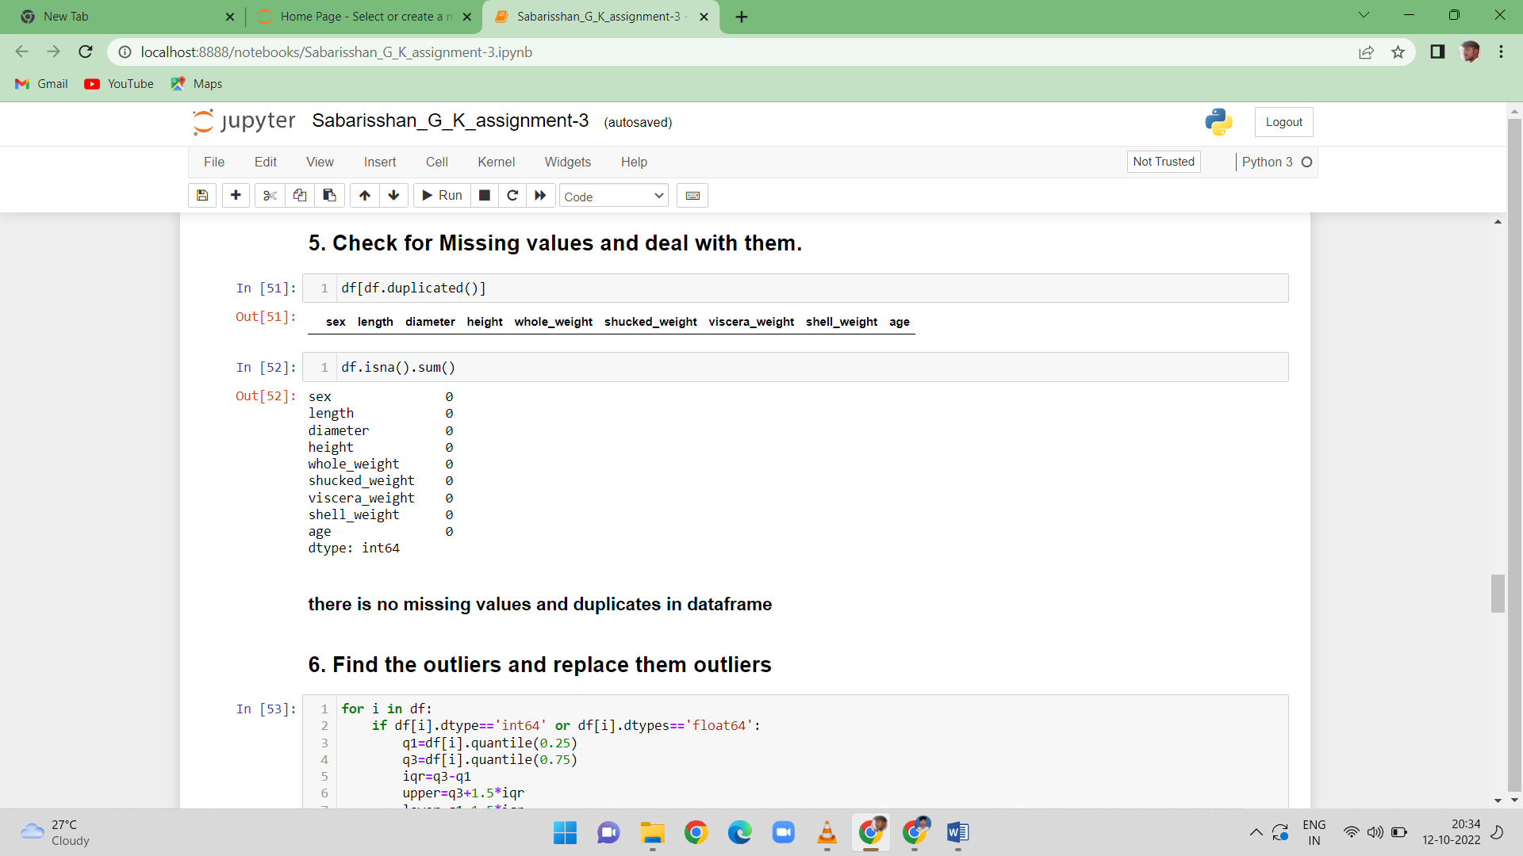

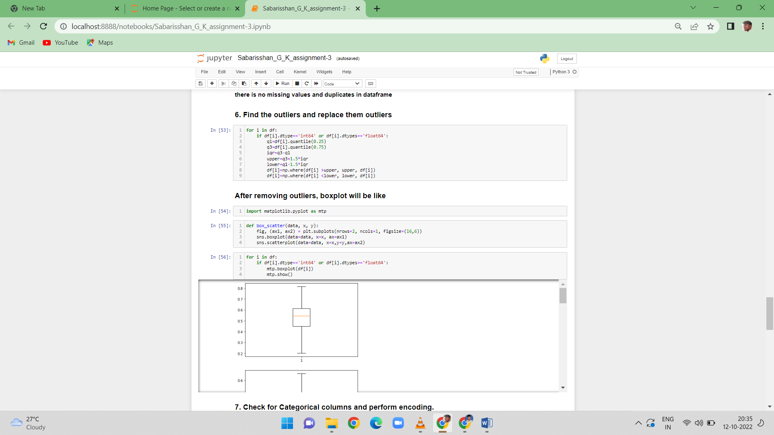

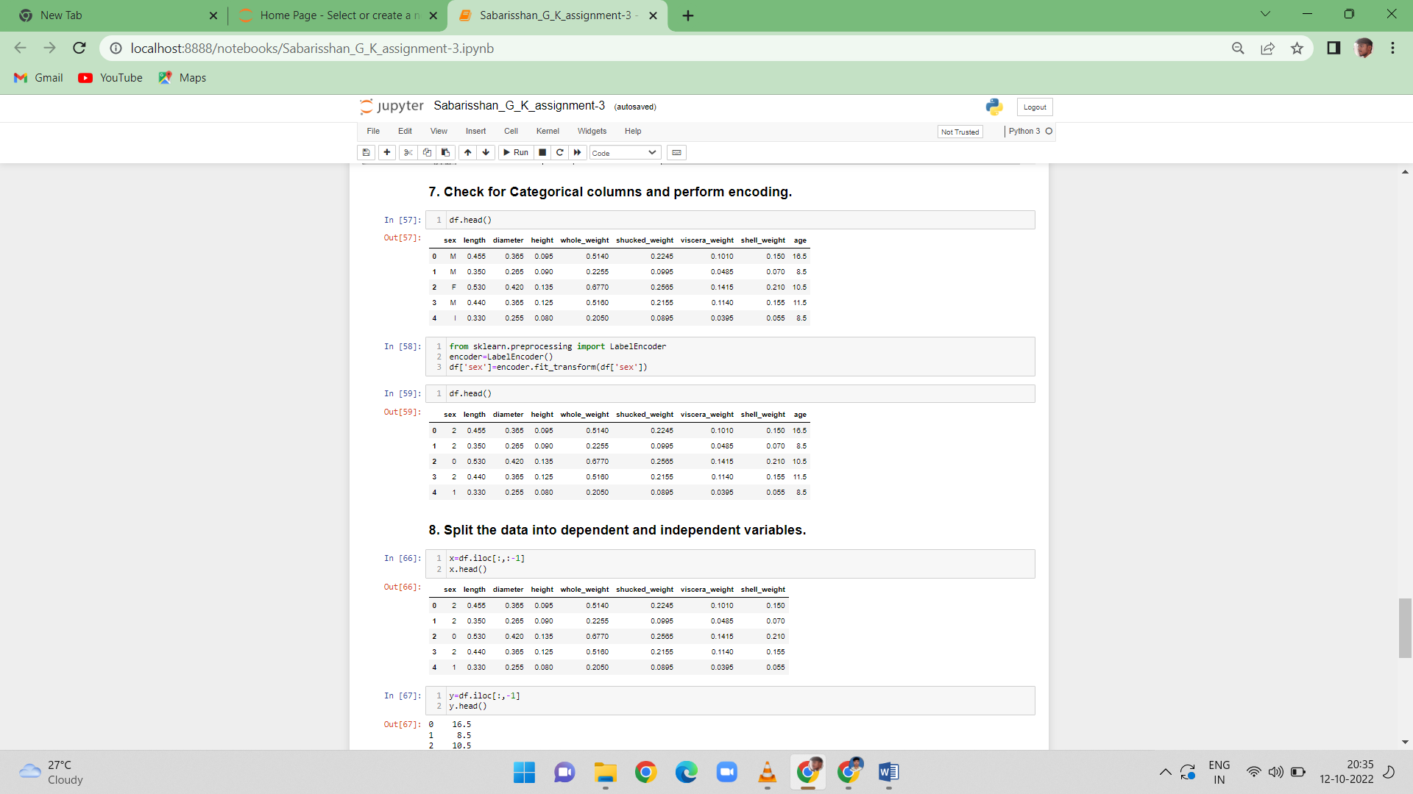

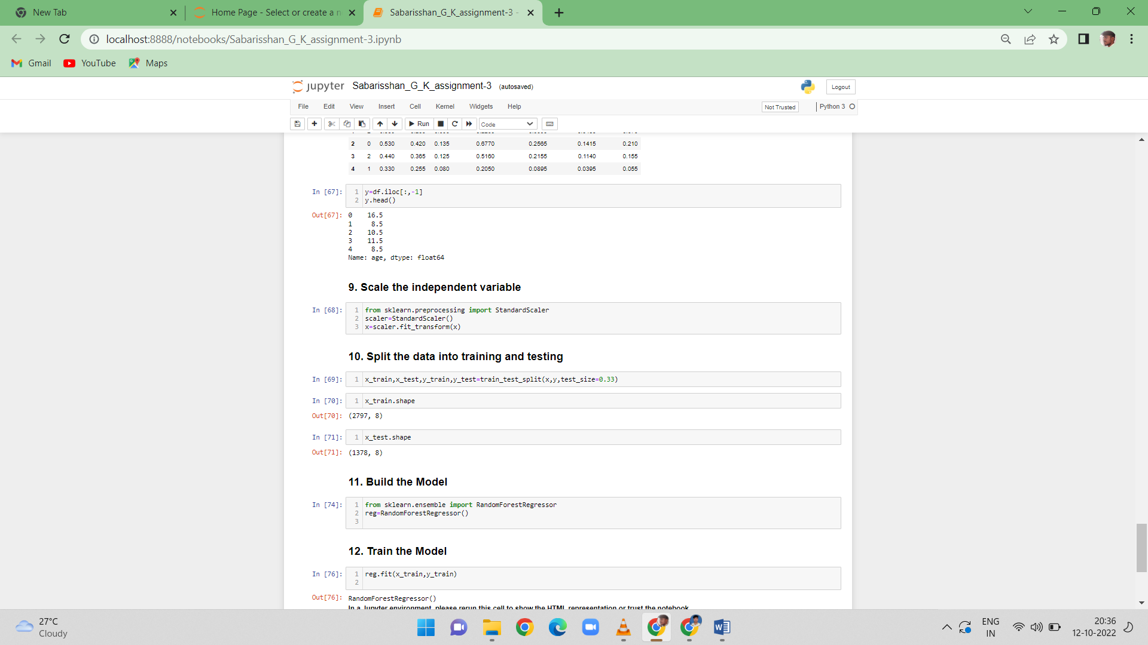

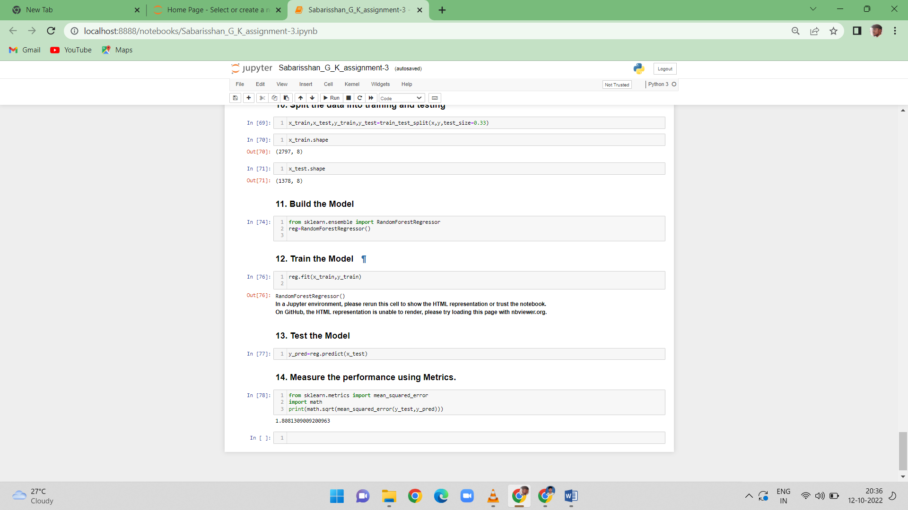

******************************THANKING YOU***********************************